BATCH HAWK
Specialty Craft Goods Price & Discovery App
Design Review Document · v0.2 · Working Draft

1. High-Level Overview
Batch Hawk is a mobile-friendly web app that aggregates pricing, availability, and promotion data from a curated list of small-batch specialty producers that offer online ordering and shipping. It gives enthusiasts a single place to compare products, prices per ounce, shipping thresholds, and active promo codes — without visiting a dozen different websites or maintaining a personal spreadsheet.

The app launches with specialty coffee as its first vertical — the most mature DTC category in the small-batch space — and is designed from the ground up to expand into adjacent categories like loose leaf tea, craft chocolate, specialty olive oil, and hot sauce. The name and data model are deliberately category-agnostic.

The app is powered by an AI-assisted browsing agent (Claude + Playwright) that periodically visits each producer's website, navigates their product catalog, and extracts structured data. It also monitors marketing emails from subscribed producers to surface promo codes and flash sales in real time. Data is stored with field-level freshness tracking so users always know how recent each piece of information is.

The initial target is individual consumers, but the data model and infrastructure are designed to scale to a broader community of contributors and eventually to a public-facing discovery platform.

2. Problem, Target Market & Solution

2.1 The Problem
Specialty coffee has exploded as a category. Dozens of high-quality independent roasters now ship nationally, many with competitive pricing, rotating single-origins, and frequent promotions. But there is no good way to compare them side by side. The information a buyer needs — bag size, price per ounce, free shipping threshold, current promos, available roast profiles — is scattered across individual websites with inconsistent layouts and no standard data format.

The result is that most buyers either stick to one or two roasters out of habit, or end up doing manual research that quickly goes stale. A buyer who wants to balance variety with value has no efficient tool to do so. This is a real friction point that currently gets solved, if at all, by personal spreadsheets that nobody wants to maintain.

The same problem applies across the broader small-batch specialty food space. Tea, chocolate, olive oil, hot sauce — all share the same pattern: passionate small producers, opaque pricing, frequent promos, and no good aggregator.

2.2 Target Market
The primary user at launch is a specialty coffee enthusiast who:
- Orders coffee online from one or more independent roasters
- Cares about price-per-ounce value but also wants variety
- Wants to know about promo codes or flash sales without subscribing to every mailing list individually
- Is comfortable with a mobile browser as their primary interface

Longer term, the same user profile applies across adjacent categories — the specialty food hobbyist who geeks out about provenance, process, and finding the best version of something they love.

The US has an estimated 9,000–10,000 roasters, of which roughly 2,000–3,000 offer meaningful national online ordering. Batch Hawk targets 50% coverage of that addressable catalog, or approximately 1,000–1,500 roasters, as a long-term goal. The early focus is a seed list of ~25 roasters from an existing personal spreadsheet, primarily Texas-based with national mail-order options included.

2.3 Why Our Solution Works
Three things differentiate Batch Hawk from a simple website list or editorial roundup:

- Structured scraping: AI-powered data collection
- Rather than brittle regex scrapers, a Claude + Playwright agent browses each producer site the way a human would, extracting pricing, bag sizes, and shipping info from varied layouts without custom per-site code.

- Honest data quality: Field-level freshness tracking
- Every data point is timestamped independently. Users see not just a price but when that price was last confirmed. A shipping threshold from two months ago is displayed differently than a price updated this morning.

- Real-time deals: Email promo intelligence
- By subscribing to producer marketing lists, the system captures promo codes and flash sales as they land — not days later when someone manually updates a spreadsheet.

2.4 High-Level System Overview
The system has four main layers:

- Producer Registry — a manually curated, moderated list of producers with their website URLs, email list URLs, and known page path hints for the agent to use. 'Producers' is the generic term; at launch these are all coffee roasters.
- AI Browsing Agent — a scheduled worker that uses Claude + Playwright to visit producer sites, extract product and shipping data, navigate to checkout (but not complete payment) for shipping cost estimation, and write structured observations back to the database
- Email Monitor — an AWS SES-powered inbox that subscribes to producer marketing lists and uses Claude to parse incoming emails for promo codes, discount details, and expiration dates
- Web App — a React + TypeScript mobile-first web app where users browse, filter, compare, and discover products with all aggregated data displayed alongside freshness indicators

3. Technical Design

3.1 Data Model
The data model is split into several core tables. Key design principle: every scraped field is stored as an independent observation with its own timestamp, rather than a single versioned snapshot per run. This enables field-level freshness queries. The term 'producer' is used generically — at launch, all producers are coffee roasters, but the schema supports any category.

producers
id uuid, primary key
name text
category enum -- coffee | tea | chocolate | olive_oil | hot_sauce | other
url text
email_list_url text
url_hints jsonb -- known paths agent should check first
fulfillment_type enum -- ship | local | both
is_active boolean
submitted_by uuid -- null = staff, else user id
moderation_status enum -- pending | approved | rejected
created_at timestamptz

field_observations (producer-level facts)
id uuid, primary key
producer_id uuid, foreign key
field_name text -- e.g. 'shipping_threshold', 'shipping_carrier'
value jsonb -- null = agent tried and could not find it
scraped_at timestamptz
source enum -- agent | manual | email
agent_run_id uuid
confidence float -- 0.0 to 1.0, agent self-assessed

products
id uuid, primary key
producer_id uuid, foreign key
name text
roast_level enum -- light | medium | medium-dark | dark
product_type enum -- single_origin | blend
origin_country text -- e.g. 'Ethiopia', 'Colombia', 'Peru'
origin_region text -- e.g. 'Guji', 'Huehuetenango'
process enum -- washed | natural | honey | anaerobic | other
brew_methods text[] -- e.g. ['pour_over','espresso','cold_brew']
flavor_profile text[] -- e.g. ['blueberry','chocolate','jasmine']
is_decaf boolean
availability_type enum -- standard | limited | seasonal
description text -- full product description as scraped
is_active boolean

Flavor profile and brew methods are stored as arrays to support multi-value filtering (e.g. 'show me washed Ethiopians good for pour-over with berry notes'). The agent extracts these from product descriptions and tasting notes. Origin country and region are stored separately to support both broad and granular filtering.

product_observations (per-SKU pricing)
id uuid, primary key
product_id uuid, foreign key
bag_size_oz float
price_usd numeric
price_per_oz numeric -- computed on write: price_usd / bag_size_oz
value_tier enum -- great | good | fair | premium
in_stock boolean
scraped_at timestamptz
agent_run_id uuid

price_per_oz is computed and stored (not just derived at query time) to keep sort/filter queries fast. value_tier is computed on write using percentile thresholds across all active products: bottom 25% = 'great', 26–50% = 'good', 51–75% = 'fair', top 25% = 'premium'. Thresholds are recalculated nightly. The UI displays value_tier as a simple icon (e.g. $$$ scale or colored badge) — not a judgment, just a relative indicator.

promos
id uuid, primary key
producer_id uuid, foreign key
code text
discount_type enum -- percent | fixed | free_shipping | bogo
discount_value numeric
applies_to text -- e.g. 'sitewide', 'single origins'
expires_at timestamptz -- null = unknown
source enum -- email | web
discovered_at timestamptz

agent_runs
id uuid, primary key
producer_id uuid, foreign key
started_at timestamptz
completed_at timestamptz
status enum -- success | partial | failed
fields_attempted text[]
fields_found text[]
feedback_notes text -- agent-generated suggestions for data model
checkout_notes text -- edge cases discovered (e.g. 2-bag limit)

3.2 Freshness Query Pattern
When displaying data, we want the most recent non-null value for each field, along with the timestamp of that observation. In Postgres this is a DISTINCT ON query:

SELECT DISTINCT ON (producer_id, field_name)
producer_id, field_name, value, scraped_at
FROM field_observations
WHERE producer_id = $1
AND value IS NOT NULL
ORDER BY producer_id, field_name, scraped_at DESC;

This gives one row per field per producer, representing the last time the agent successfully found that value. Null observations are still written to the database (source of truth that the agent tried) but filtered out in this read query. The UI displays both the value and the scraped_at timestamp, styled by age (e.g. green < 2 days, yellow < 14 days, red = older).

3.3 Platform-Aware Scraping Strategy
Not all producers require the same scraping approach. The agent uses a tiered strategy, attempting the cheapest method first and escalating only when needed. Initial analysis of the seed list suggests 60–70% of roasters are on Shopify, dramatically reducing token costs.

Tier 1 — Shopify /products.json (free, no Claude required)
Every Shopify store exposes a public unauthenticated endpoint at /products.json returning full catalog data including variants, prices, availability, and SKUs. No API key, no token, no Playwright — just an HTTP GET.
GET https://{store-domain}/products.json?limit=250
-- Returns: id, title, vendor, tags, variants[],
-- variants[].price, variants[].available,
-- variants[].title (bag size often here)

Platform detection: presence of 'cdn.shopify.com' in page source or 'Powered by Shopify' in footer confirms Shopify. Stored once as platform_type in the producers table — all future product scrapes skip Playwright entirely for that producer.

Additional free Shopify endpoints:
- /collections/{handle}/products.json — products within a specific collection
- /products/{handle}.json — single product with full variant detail
- /pages/shipping — often contains plain-text shipping threshold info (no cart required)

Happy Mug (confirmed Shopify) has a dedicated /pages/shipping-table. This kind of url_hint is stored after first discovery and reused on every subsequent run.

Tier 2 — Network response interception (low cost)
During Playwright page load, the agent intercepts XHR/fetch responses before Claude reads anything. On non-Shopify stores, storefronts frequently call their own APIs and return clean JSON. If a useful response is intercepted, Claude is not invoked for product extraction.

Tier 3 — Claude reads page text (standard cost)
For stores where Tiers 1 and 2 yield nothing (e.g. Squarespace stores like Noble Coyote), Playwright loads the page and Claude reads the rendered text. Specialty coffee product names are richly structured — origin, process, and tasting notes are typically in the product title or description, which Claude extracts into structured fields in one pass.

Noble Coyote example: 'Ethiopia Guji Kayon Mountain Farm Natural Process Organic — Blueberry, Maple, Baking Spice' parses into origin_country=Ethiopia, origin_region=Guji, process=natural, flavor_profile=[blueberry, maple, baking spice] in a single Claude call.

3.4 Search, Filtering & Query Design
Batch Hawk users are enthusiasts who want to slice data in complex ways. The search and filter system supports this from day one, with both a visual filter panel and a JQL-style text query bar for power users.

Filter dimensions
- Producer: name, location (city/state), fulfillment type
- Product type: single origin vs. blend
- Origin: country, region — multi-select
- Roast level: light, medium, medium-dark, dark — multi-select
- Process: washed, natural, honey, anaerobic — multi-select
- Brew method: pour over, espresso, cold brew, french press, etc. — multi-select
- Flavor profile: tag-based multi-select (e.g. chocolate, floral, citrus, berry)
- Availability: standard, limited, seasonal
- Decaf: boolean
- Price per oz: range slider or value tier badge filter
- Free shipping: boolean
- Active promo: boolean (non-expired promo code exists)
- Data freshness: filter by how recently pricing was confirmed

Sort options
- Price per oz ascending / descending
- Most recently updated
- Alphabetical by producer or product
- Value tier
- Free shipping threshold low to high

Value tier display
Price per oz is computed at write time and stored directly on product_observations. Value tier (great / good / fair / premium) is assigned nightly using percentile thresholds across all active products: bottom 25% = great, 26–50% = good, 51–75% = fair, top 25% = premium. The UI displays this as a simple visual badge — a relative indicator, not a quality judgment. Tooltips explain the methodology so users understand what they're seeing.

JQL-style query language
A Jira-style text query bar allows compound boolean queries without navigating multiple filter dropdowns. The parser runs on the backend and translates to a parameterized Postgres query.

Example queries:
origin = Ethiopia AND process = natural AND roast = light
origin IN (Ethiopia, Kenya) AND price_per_oz < 1.50
brew_method = espresso AND value_tier IN (great, good)
has_promo = true AND free_shipping = true
origin = Colombia AND flavor HAS chocolate AND NOT decaf
availability = limited ORDER BY price_per_oz ASC
producer.location = Austin AND roast IN (light, medium)

Supported operators:
- = / != — exact match
- IN (...) / NOT IN (...) — multi-value match
- HAS — array contains, for flavor_profile and brew_methods
- < / > / <= / >= — numeric range for price_per_oz, bag_size_oz
- AND / OR / NOT — boolean logic
- ORDER BY [field] ASC | DESC

The query bar will support autocomplete for field names and known enum values (origin countries, flavor tags, etc.) to reduce friction. Saved searches are a natural future premium feature — e.g. 'notify me when an Ethiopian natural under $1.40/oz appears with an active promo.'

Similarity & recommendations (future)
With flavor_profile, origin, roast_level, and process stored as structured fields, a cosine similarity score can be computed between products to power 'if you liked X, try Y' recommendations. Alternatively, user save/favorite behavior can train a lightweight collaborative filter. The data model supports this from day one — it is not an MVP feature.

3.5 AI Browsing Agent
The agent is a scheduled Spring Boot worker that iterates through active producers and runs a scraping session per producer using the tiered strategy described in section 3.3. For Tier 3 sessions, Claude + Playwright is invoked. Each Claude session:

- Checks url_hints first before searching for the catalog
- Extracts products with all structured fields: name, origin, process, roast, brew methods, flavor profile, availability type, bag sizes, prices
- Navigates to the shipping or FAQ page to find threshold and carrier info before attempting cart
- Adds one item to cart and proceeds to checkout for shipping rate estimate using Austin TX 78701 as the canonical test address — stops before payment submission
- Writes all found values as new field_observation and product_observation rows
- Writes null observations for any fields attempted but not found
- Appends feedback_notes for anything the current data model cannot capture

Scrape rate at 1,500 producers with 7-day freshness target: ~9/hour. Single worker process, no exotic infrastructure.

Bot detection mitigations for Shopify checkout:
- Prefer the shipping policy page first — captures rate without cart in ~40–50% of cases
- Realistic browser fingerprinting via Playwright defaults
- Rate-limit sessions per producer to no more than once per 6 hours
- Manual override queue for producers where shipping rate cannot be determined automatically

3.6 Email Monitor
The system subscribes one monitored inbox to each producer's marketing list. The email pipeline is fully AWS-native:

- AWS SES receives inbound email for a monitored domain (e.g. roasters@batchhawk.com)
- SES stores the raw .eml to an S3 bucket and triggers an EventBridge rule (or SNS -> SQS) on receipt
- The scraping service worker polls the SQS queue, pulls the raw email from S3 by key, and passes it to Claude for parsing
- Claude extracts structured promo data: code, discount type and value, applies-to scope, expiration date, and urgency signal
- Producer matching uses the From address first; Claude identifies the producer name as a fallback if the From domain does not match a known record
- Output is written as a new row in the promos table with source = 'email' and discovered_at timestamp

This keeps all email infrastructure inside the existing AWS account. No third-party email parsing service needed. SES inbound is available in us-east-1 and us-west-2.

3.7 Manual Override & Admin Tools
Several scenarios require human intervention. The admin interface (developer-facing, not user-facing) surfaces:
- Producers with one or more null-only observations for a given field (agent could not find it)
- Producers where checkout was blocked or shipping rate could not be determined
- User-submitted producers awaiting moderation
- Agent feedback_notes flagging data model gaps

Manual overrides write to field_observations with source = 'manual', so they participate in the same freshness query and are displayed with an accurate timestamp.

3.8 Shipping & Tax Notes
Shipping rates are location-dependent. The app will use a canonical test address (Austin, TX 78701) for all agent-sourced shipping estimates and will display a disclosure to this effect in the UI. Users understand their actual rate may differ.

Tax will not be displayed or estimated. This is a known simplification. Users are expected to know they will pay applicable sales tax at checkout.

3.9 User-Contributed Data & Accounts
User accounts are optional — the app is fully browsable without login. Accounts unlock:
- Saving favorite producers
- Commenting on producers (moderated)

Reviews are intentionally excluded. The trust problem with reviews on a platform like this is significant — producers have obvious incentive to seed positive reviews and there is no reliable way to verify purchases. The objective pricing and freshness data is more useful than unverifiable subjective ratings. This decision can be revisited if the community grows to a point where verified-purchase gating becomes feasible.

User-submitted producers follow a moderation queue (moderation_status = pending) and require developer approval before becoming visible. Comments are also moderated.

3.10 Infrastructure & Tech Stack
Backend: Spring Boot / Kotlin. Natural fit for the scheduled worker model (Spring Scheduler or Quartz for agent job dispatch) and REST API serving.

Database: PostgreSQL on AWS RDS. The DISTINCT ON freshness query pattern is Postgres-native. RDS fits naturally in the existing ECS VPC.

Compute: AWS ECS (Fargate). Existing Terraform from a prior ECS project will be adapted. Two primary services:
- API service — Spring Boot REST API, stateless, scales horizontally
- Worker service — Spring Boot scraping agent, single instance, runs scheduled Playwright + Claude jobs and polls the SQS email queue

Frontend: React + TypeScript, mobile-first responsive web app. No native iOS app at launch — the mobile web experience is the primary mobile surface.

Browser automation: Playwright inside the worker container with a bundled Chromium install. Claude directs Playwright via the Anthropic API.

Email: AWS SES inbound + S3 + SQS, as described in section 3.6.

CI/CD pipeline and Terraform state from prior ECS project will be reused and adapted, not rebuilt from scratch.

3.11 Monetization Strategy
No monetization is required at MVP — the app can launch as a free personal utility. The following options are ranked by feasibility at small scale:

- 1.: Affiliate / referral links (highest priority)
- Many Shopify-based producers have affiliate programs via ShareASale, Impact, or their own systems. Outbound links are tagged with an affiliate parameter. Typical commission: 5–15% of order value. No user friction. Aligns naturally with the app's purpose.

- 2.: Freemium feature gating
- Free tier: browse and search. Paid tier ($2–4/month or one-time): JQL query bar, promo alerts, saved searches, saved favorites. Key: free tier must be genuinely useful or acquisition fails.

- 3.: Featured producer placements
- Clearly labeled promoted slots at the top of results. Only viable once meaningful traffic exists. Even 5–10 producers at $50–100/month would cover AWS costs comfortably.

Monetization is not a launch blocker. Start with affiliate links (lowest friction, highest alignment) and evaluate after initial traction.

3.12 API Cost Model
The scraping agent uses the Anthropic API for two tasks: webpage extraction (Haiku 4.5) and email parsing (Sonnet 4.6). Cost estimates assume the Batch API (50% discount), appropriate since scraping runs on a weekly schedule. Shopify /products.json calls cost $0 in API tokens.

Per producer per scrape run — Tier 3 (Claude required) only:
- Input: ~30,000 tokens — system prompt, url_hints, 4–6 pages of webpage text
- Output: ~1,500 tokens — structured JSON extraction + agent notes

Cost at 25 roasters, weekly, using Haiku 4.5 with Batch API (~$0.50/$2.50 per MTok):
- Input: 25 × 30K × $0.50/M = $0.375/week → ~$1.50/month
- Output: 25 × 1.5K × $2.50/M = $0.094/week → ~$0.38/month
- Total: under $2/month at launch scale

At 1,500 roasters (long-term) with Sonnet 4.6 + Batch API (~$1.50/$7.50 per MTok):
- Input: 1,500 × 30K × $1.50/M = $67.50/week → ~$270/month
- Output: 1,500 × 1.5K × $7.50/M = $16.88/week → ~$68/month
- Total: ~$340/month at full scale — manageable if affiliate revenue is active

Strategy: use Haiku 4.5 for routine structured extraction (fast, cheap, accurate enough). Escalate to Sonnet only when Haiku confidence is low or the agent run fails. Email parsing uses Sonnet since nuance matters more there, but email volume is low.

4. Open Questions
The items below are unresolved. All previously open items have been resolved and are noted below.

RESOLVED
- App name: Batch Hawk — batchhawk.com domain to be registered (verify trademark at tmsearch.uspto.gov first)
- Backend: Spring Boot / Kotlin on AWS ECS (Fargate)
- Database: PostgreSQL on AWS RDS
- Frontend: React + TypeScript, mobile-first responsive web app
- No iOS app at v1 — mobile web is the mobile experience
- Email infrastructure: AWS SES inbound + S3 + SQS
- SES inbound domain: batchhawk.com (pending domain registration)
- Shipping test address: Austin TX 78701
- Tax: not displayed or estimated
- Monetization starting point: affiliate links first, freemium gating second
- User accounts: optional, unlock saved producers and comments — no reviews at launch
- Starter producer list: ~25 coffee roasters from existing personal spreadsheet
- Scraping model: Haiku 4.5 (Batch API) for extraction, Sonnet 4.6 for email and fallback
- Estimated API cost at launch: under $2/month
- Future verticals: loose leaf tea, craft chocolate, specialty olive oil, hot sauce — schema is category-agnostic from day one

Q1. Primary sort and filter UX: what are the most important ways users should be able to slice the data at launch? (e.g. price/oz ascending, origin region, roast level, free shipping threshold, most recently updated, active promo)
Answer: _______________________________________________________________
Q2. Claude API account: personal Anthropic account or a dedicated project account for Batch Hawk? What monthly API spend would trigger a desire to optimize model selection or prompt caching strategy?
Answer: _______________________________________________________________

5. Repository & Module Structure
Batch Hawk uses a single monorepo with four independent modules. This keeps the codebase searchable and the CI pipeline unified while allowing each module to deploy independently on ECS with its own Docker image, task definition, and resource allocation.

Rationale for monorepo over separate repositories: one developer, one CI pipeline, shared grep/search, no cross-repo versioning overhead. Module boundaries provide the separation that matters for deployment without the friction of separate repos.

Repository Layout
batchhawk/
├── api/ ← Spring Boot REST API (Kotlin)
│ ├── src/
│ ├── Dockerfile
│ └── build.gradle.kts
├── worker/ ← Spring Boot scraping + email agent (Kotlin)
│ ├── src/
│ ├── Dockerfile ← includes Chromium/Playwright
│ └── build.gradle.kts
├── web/ ← React + TypeScript frontend
│ ├── src/
│ ├── Dockerfile
│ └── package.json
├── infra/ ← Terraform (ECS, RDS, SES, SQS, S3, IAM)
│ ├── main.tf
│ ├── ecs.tf
│ ├── rds.tf
│ ├── ses.tf
│ └── variables.tf
├── shared/ ← Kotlin shared domain models (optional, add when needed)
├── docker-compose.yml ← local dev: api + worker + postgres
└── build.gradle.kts ← Gradle multi-project root

5.1 Module Responsibilities

api/
Spring Boot REST API. Serves the React frontend and any future third-party consumers. Stateless, horizontally scalable. Handles all user-facing reads (browse, search, filter, JQL query parsing) and user account writes (saves, comments). Does not run scraping logic. ECS task: low memory, auto-scaling.

- Owns the JQL query parser — translates text queries to parameterized Postgres queries
- Exposes REST endpoints consumed by web/
- Handles user auth (JWT or session), account management, saves, comments
- Reads from Postgres using the freshness query pattern (DISTINCT ON)
- Writes user-generated data: accounts, saves, comments, submitted producers

worker/
Spring Boot scheduled worker. The only service that writes scraped data to the database. Runs on a long-lived ECS task with higher memory allocation (Chromium is heavyweight). Not exposed to the internet — internal only, inside the VPC.

- Scheduler: Spring Scheduler (or Quartz for more complex job management) drives the scraping cadence
- Scraping agent: tiered strategy — Shopify /products.json → network intercept → Claude + Playwright
- Email pipeline: polls SQS queue, fetches .eml from S3, sends to Claude for parsing, writes to promos table
- Direct Postgres access — no API hop for writes; trusted internal service on the same VPC
- Writes: field_observations, product_observations, agent_runs, promos
- Dockerfile includes Chromium install alongside the JVM

web/
React + TypeScript frontend. Mobile-first responsive web app. Served via CloudFront or an ECS nginx container. Consumes the api/ REST endpoints. Contains no business logic — purely presentation and user interaction.

infra/
Terraform configuration for all AWS infrastructure. Adapted from a prior ECS project — not rebuilt from scratch. Covers:
- ECS cluster with two services: api task definition and worker task definition
- RDS Postgres instance (private subnet, accessible only within VPC)
- SES inbound configuration + S3 bucket for raw email storage
- SQS queue for email processing
- IAM roles: api service role (read-only S3, no SQS), worker service role (SQS consume, S3 read, RDS write)
- CloudFront distribution for web/
- Security groups: worker and api can reach RDS; worker can reach SQS; nothing reaches worker from internet

5.2 Database Access Model
Both api/ and worker/ connect to the same RDS Postgres instance inside the VPC. They use separate database users with different permission sets:

batchhawk_api — SELECT on all tables, INSERT/UPDATE on user tables only
(accounts, saves, comments, submitted_producers)
batchhawk_worker — SELECT/INSERT on all tables
(field_observations, product_observations, agent_runs,
promos, products, producers)

The worker never exposes a network endpoint. API never writes scraping data. This separation is enforced at the database permission level, not just by convention.

5.3 Local Development
A single docker-compose.yml at the repo root brings up the full stack locally:
services:
postgres: # RDS equivalent
api: # api/ with hot reload
worker: # worker/ with hot reload
web: # React dev server with HMR

The worker's Playwright/Chromium dependency makes the worker container image large (~500MB+). For local dev, developers can run the worker natively (Playwright installs locally) and only containerize for deployment. The api and web services are lightweight enough to always run in Docker locally.

6. UI Mockups
The following screens illustrate the intended design direction. Warm cream and amber palette, Playfair Display for product names, DM Mono for prices and code. Mobile-first — the phone screens are the primary design target.

6.1 Mobile — Results Feed
The main browse view. Filter chips show active JQL query dimensions. Product cards show origin/process/flavor tags, value tier badge, price-per-oz, free shipping threshold, and active promo code where present.

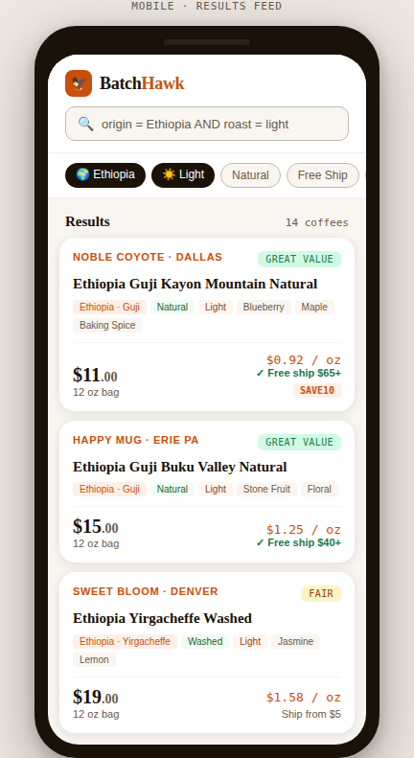

6.2 Mobile — JQL Search
Dark-mode search screen with syntax-highlighted query tokens. Inline result preview as you type. Autocomplete chips for common query completions. Results count shown before committing the search.

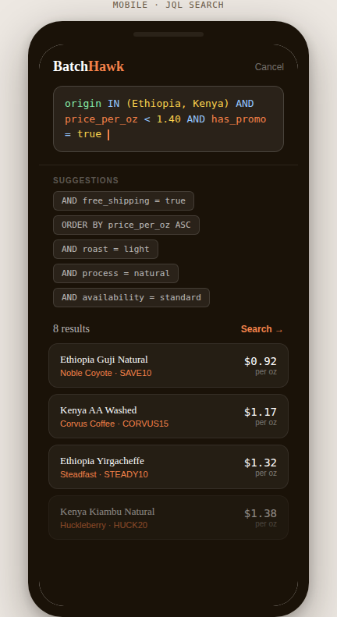

6.3 Mobile — Product Detail
Hero header with dark background, producer name, full product name, price and price-per-oz. Below: structured profile grid, flavor note pills, shipping info, and the field-level freshness bar showing per-field timestamps with green/yellow/red age indicators. CTA links out to the roaster site (affiliate-tagged).

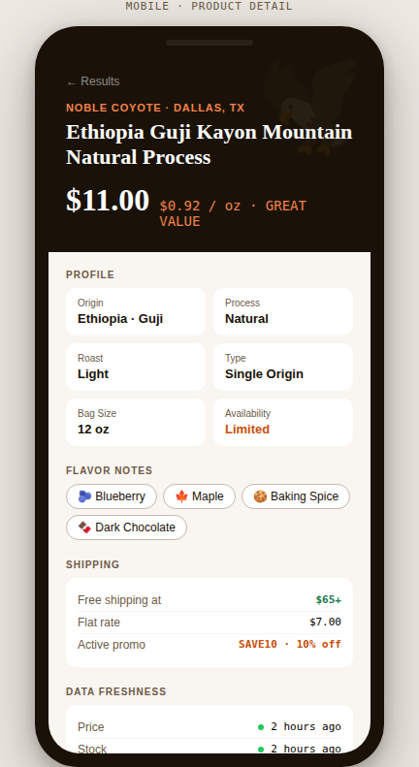

6.4 Desktop — Browse & Filter
Two-column layout: sidebar filter panel with checkboxes and counts, main area with product card grid. JQL bar in the top nav. Price-per-oz range slider in sidebar. Austin TX shipping disclosure in results header. All the same data as mobile, more visible at once.

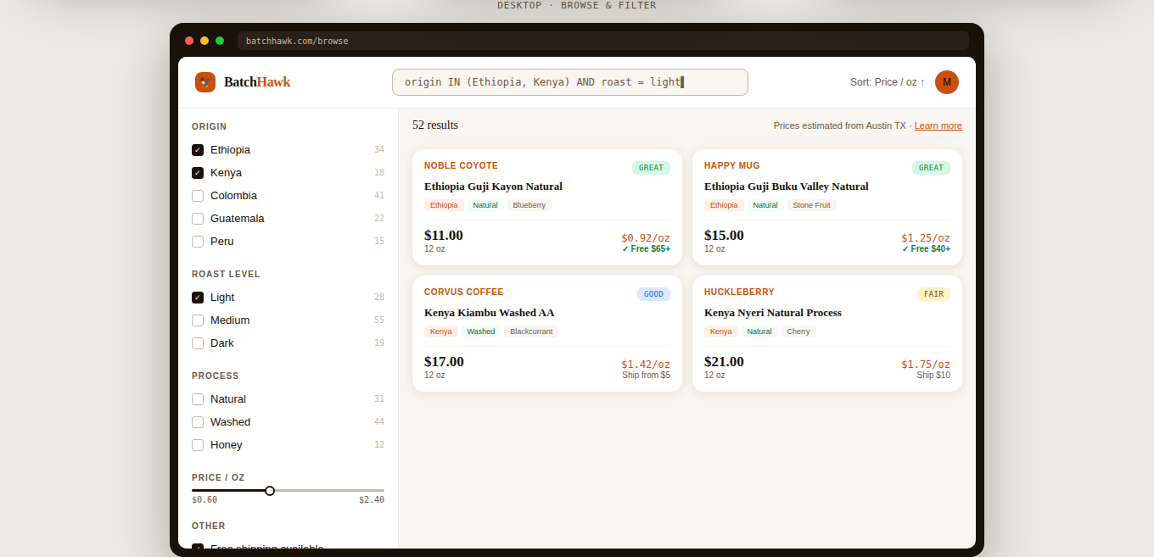

Batch Hawk Design Review · v0.3 · Final Draft · Not for distribution

